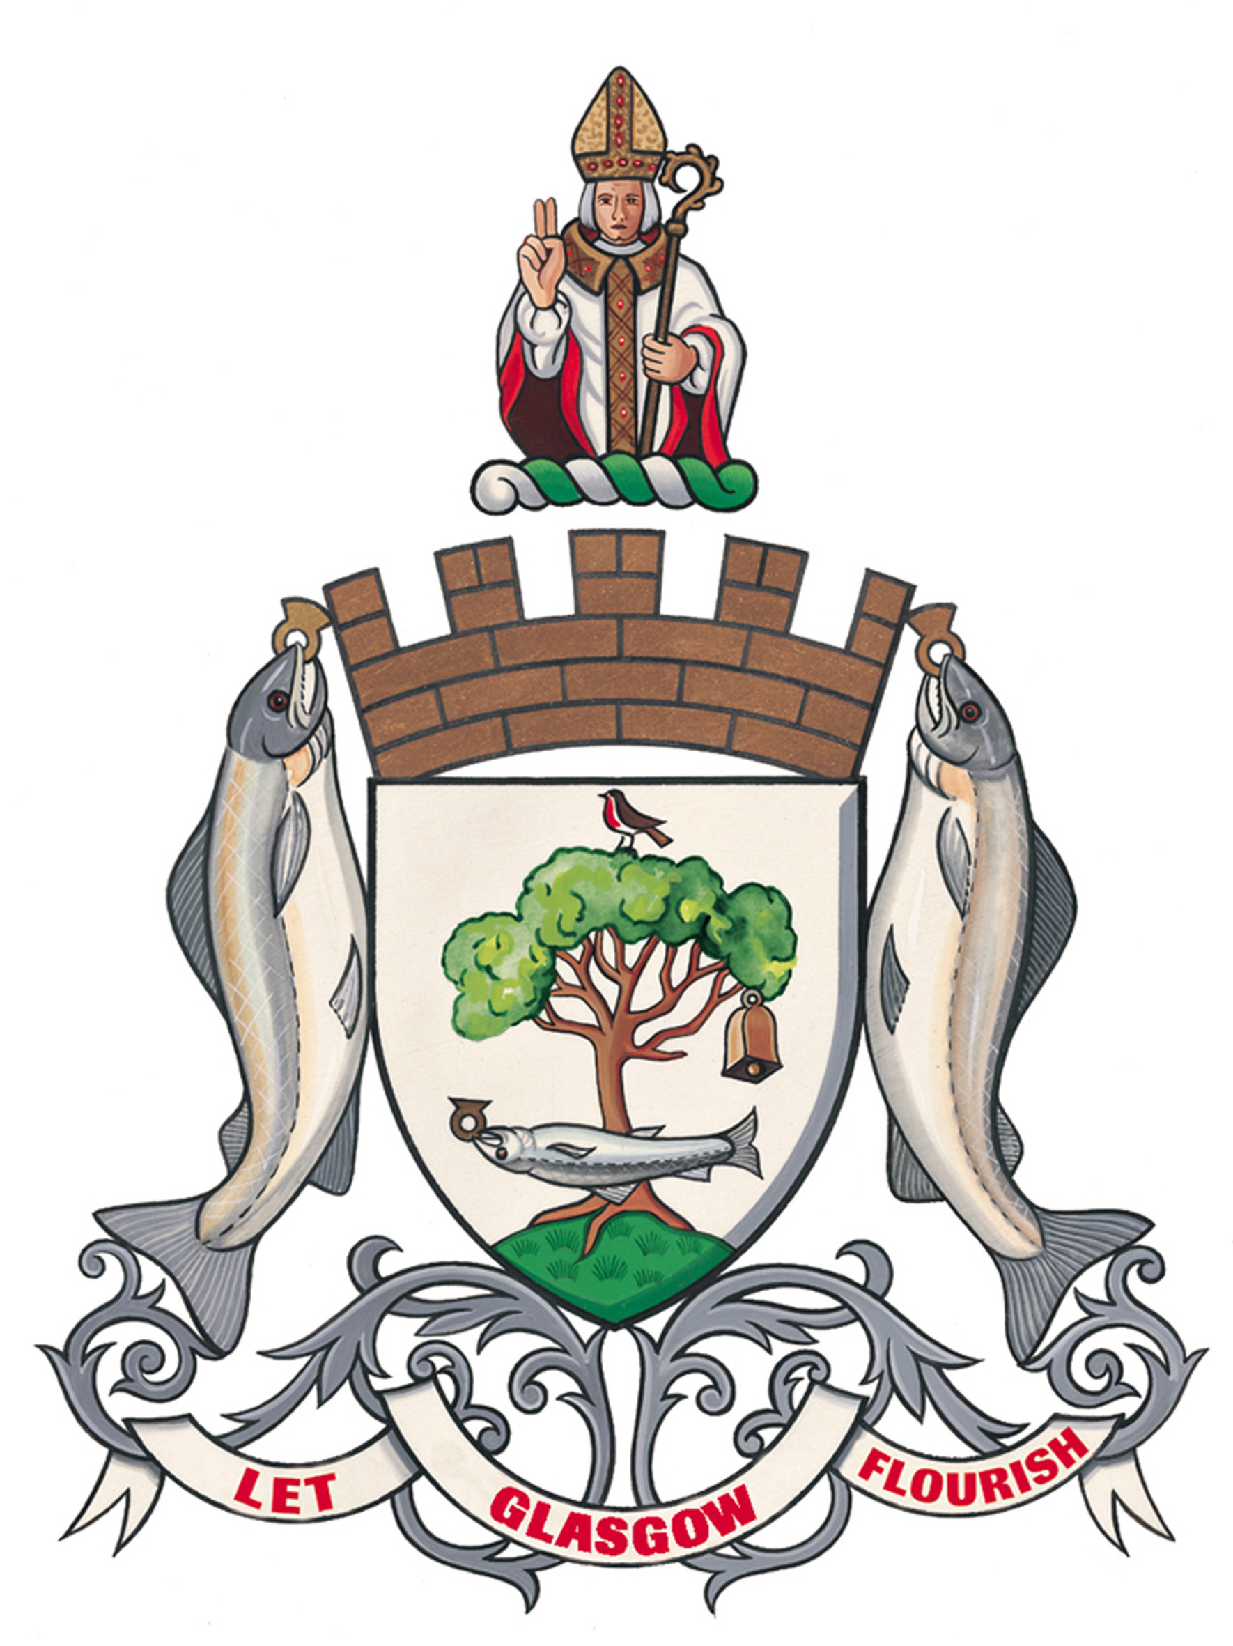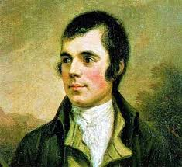

The Lord Provost’s
Poetry Prize

2016

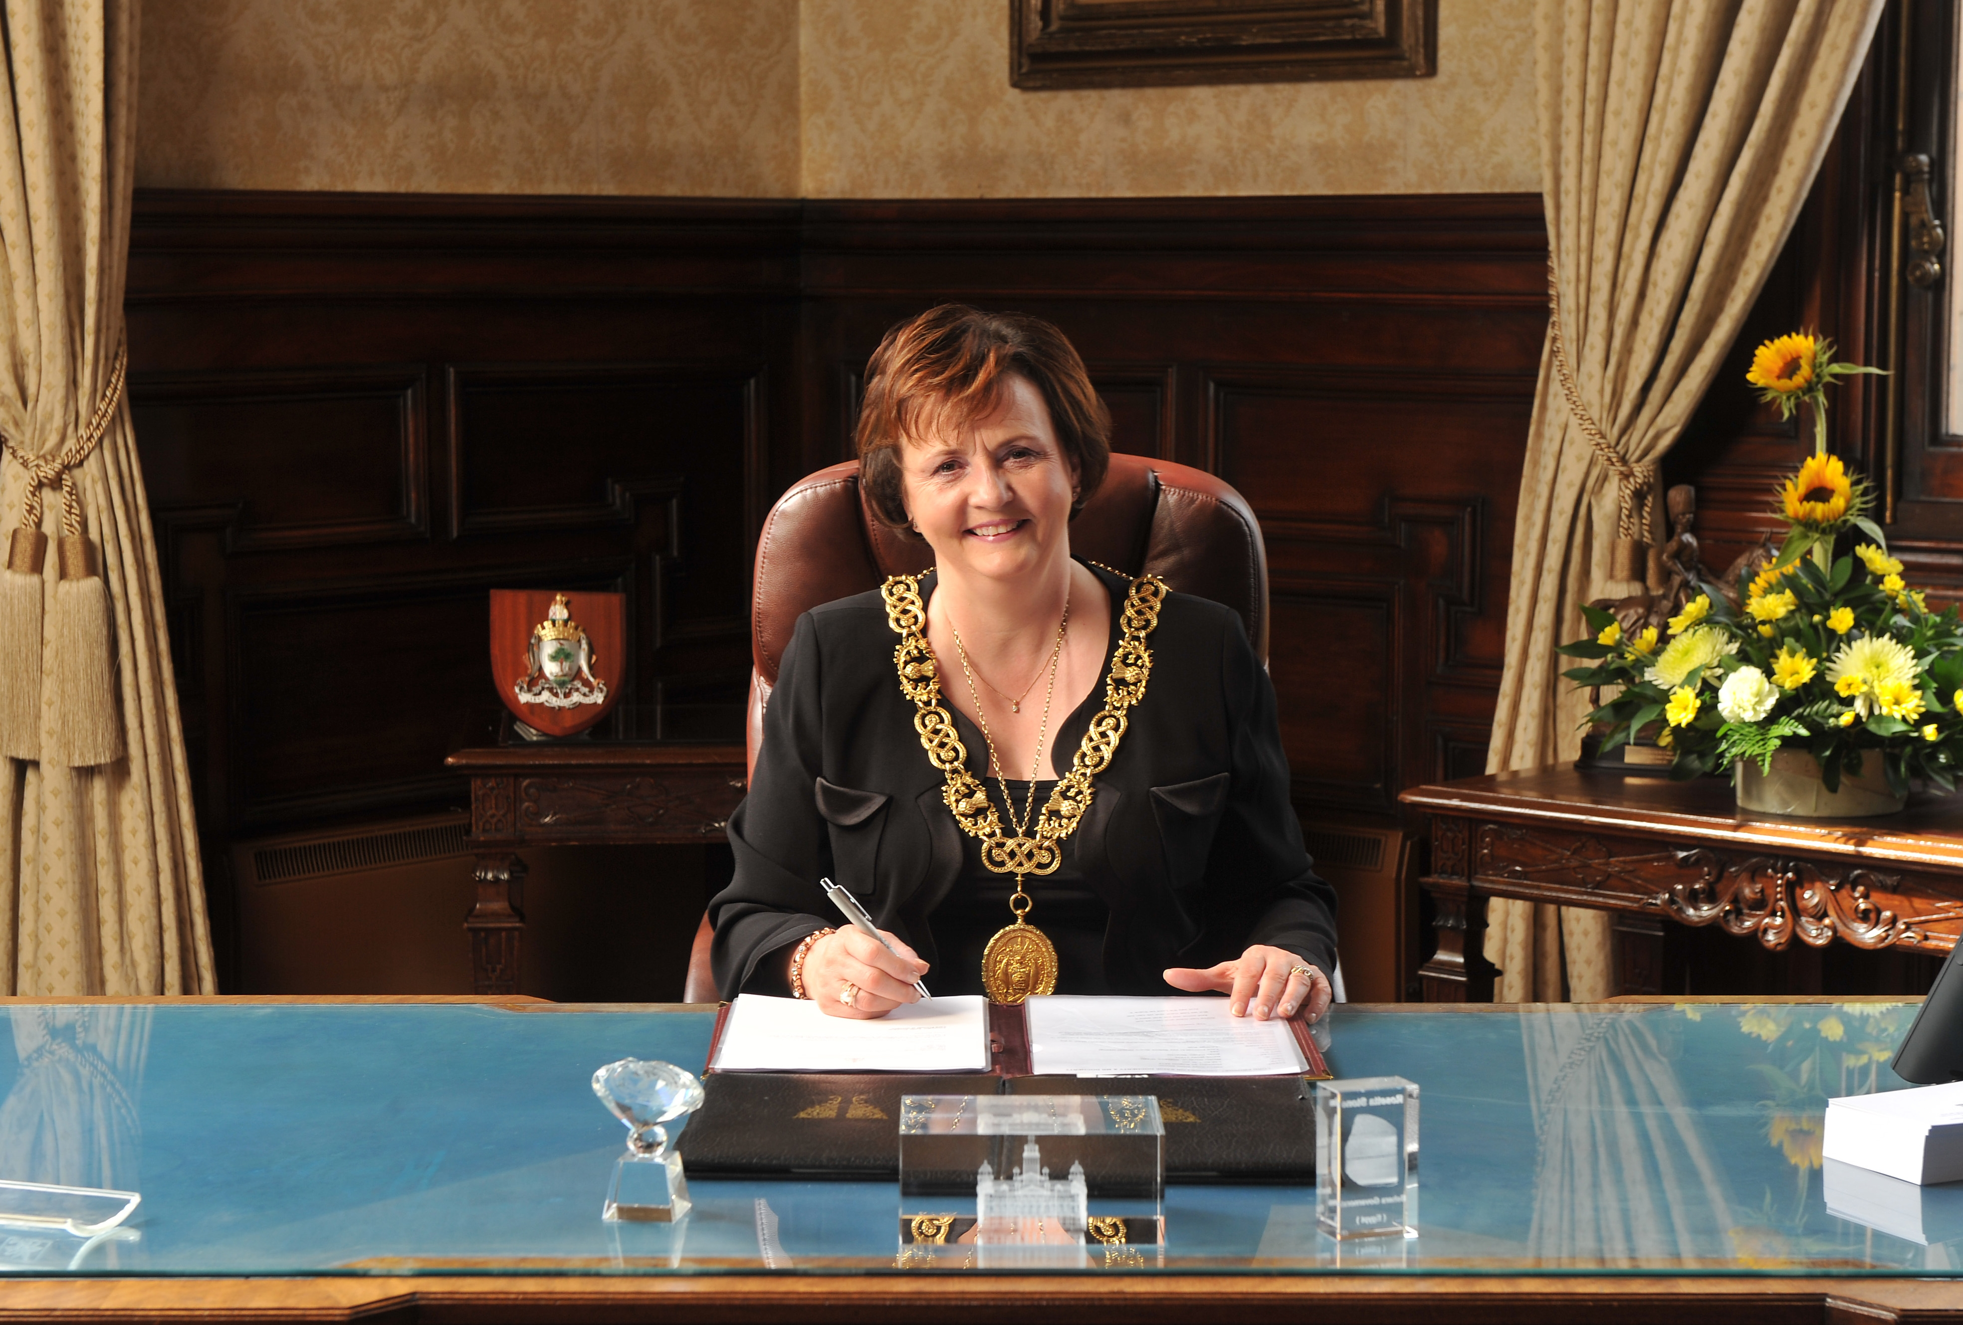

FOREWORD

This poetry competition has caught the imagination of this city’s children and proves that poetry remains a popular form of expression. We’ve been overwhelmed at the quality and quantity of entries.

It proves that poetry is a great way to communicate. It also demonstrates how talented Glasgow’s children are. I’m sure Scotland’s Bard Rabbie Burns would whole-heartedly approve.

Each child’s poem is unique and celebrates their personal relationship with Glasgow. The judging panel is thrilled at the standard and variety of work submitted and we struggled to shortlist the winner and runners-up.

I hope you enjoy reading these special poems, share our delight in them and that the theme, Our City, resonates with you.

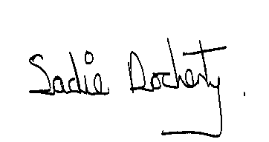

Councillor Sadie Docherty

Lord Provost of Glasgow

ACKNOWLEDGEMENTS

Simon Biggam, Glasgow Life

David Byrne, Education Services, Glasgow City Council

Jim Carruth, Glasgow Poet Laureate

Yvonne Keenan, Education Services, Glasgow City Council

And all the poets and their Primary Schools who took part in the competition.

MESSAGE FROM JIM CARRUTH
GLASGOW POET LAUREATE

What a wonderful privilege it has been to spend the last few months looking through all the poems submitted. At first we were always a bit concerned about whether there would be interest in this competition but we shouldn’t have worried because we were inundated with entries from all across the city.

Hundreds of primary children have made their own personal response to the theme of Our City making our decisions as part of the judging panel very difficult indeed. What has come across loud and clear is both the sense of pride the children have in the city but also the talent and creativity they have displayed within the work they have submitted. The poems in this booklet can only give a flavour of the wide variety of poems we received.

I would like to take this opportunity to thank all the children and their teachers for taking the time to participate.

As poet laureate for the city this has been one of the most enjoyable projects I have asked to be involved in and I look forward to seeing this competition as a permanent fixture in the Glasgow school year and also reading even more poems next year.

Jim Carruth
Glasgow Poet Laureate

Contents

First Prize

“Take A Tour Round Glasgow”
By Odaline Dhir, Notre Dame Primary School

Runner Up

“Glasgow My City”
By Eve Roger, Cardonald Primary

Runner Up

“Pollok House”
By Vincent Chen, St Teresa’s Primary School

Runner Up

“The Great Mosque”
By Zeyana Ali, Barmulloch Primary School

Runner Up

“The Unforgettable Fire”
By Rosie Barclay, Scotstoun Primary School
Take a tour around Glasgow

I’m a Glasgow lass at heart
I want to describe it but where to start
So let’s take a look high and low
Hold on tight, here we go
Let’s start our journey underground
Where the subway goes round and round
Get off at St Enoch’s station
Which despite the flurry causes no irritation
Where there’s a market during Christmas season
Even if the winds that blow are freezing
Take the tour bus from George square
It’s impossible to find parking there
Where in winter the lights go up
And so we head to our next stop
We see a statue and it’s said
People put a cone on Wellington’s head
Then get off at the Riverside
Where the roof goes up and down outside
Take a stroll to the SECC
Where events are held for you and me
Science Centre, Hydro, Cheese Grater Car Park,
Great new Architecture gives you a start
Walk along the river Clyde
With abandoned Shipyards at the side
That’s All I can tell you but you can see more
Pop over to Glasgow there’s surprises in store

By Odaline Dhir, Notre Dame Primary School

GLASGOW MY CITY

Glasgow in the summer time sees the sunburst soak the skies,
With scenery so beautiful you won’t believe your eyes.
From sunbathing out in Kelvin Park to fishing in the Clyde,
Happy people all around, with smiles a mile wide.

Ibrox, Parkhead, Partick Thistle, don’t forget Hampden Park.
At 3’oclock on weekends in winter it is dark.
Winter time in Glasgow brings the George Square Christmas lights,
The frost will freeze your fingers, stay wrapped up warm at nights.

Glasgow Green in Autumn sees the golden brown leaves fall.
Art galleries, museums, this city has it all.

The Hydro and the Squinty Bridge, reaches far across the river,
Glaswegians welcome everyone, with open arms whenever.
Glasgow in the Spring time sees the birds nest in the trees,
Blue bells in the woods, their seeds spread in the breeze.

Glasgow is my city, Glasgow’s where I roam,
Glasgow is where I was born,
GLASGOW IS MY HOME!!!!!!!!

Eve Roger, P7a, Cardonald Primary

Pollok House

I see the tall tree towering over me like I’m an ant.
The grass so green as far as the eye can see.
I see the mother cattle protect their young like shields.
The flowers all different colours like a rainbow.
The tall house worn away by time, but stunning and magnificent all at the same time.
I see the great river flowing like a sea of blue,
The bridge old as the river itself.
The forest glistening and shimmering like a diamond.
I see the sun rising in the west, the sight of it is magnificent and never gets old.

Vincent Chen, Primary Seven, St Teresa’s Primary
The Great Mosque

The central mosque was built in 1983;
Outside the mosque is a great garden you see

On Eid I always go there to pray,
and after I finish, it makes my day

Never miss the sorrow sight,
the tower at night has a green light

The marvellous Mosque is famous worship;
its probably as old as the last cruise ship

The terrific tall tower is called the minaret,
seeing the minaret would be gorgeously great

It would never be faithfully forgotten.

By Zeyana Ali, Barmulloch Primary School
The Unforgettable Fire

On the 23rd of May
In two o’ fourteen
Just off Sauchiehall Street
Many flames and smoke were seen.

When an art student’s project
Made of foam and flammable gases
Was lit by a projector
The building turned to ashes.

Many believed it was
A conspiratorial event
But really the flames travelled through
An old, unused vent.

Once the flames had all died down,
And the smoke had gone away,
The investigators found
Intact treasures stowed away.

Among the rare artefacts
Recovered from the blaze,
Was a painting of a sentry
In the last minutes of Pompeii.

A scared look upon his face
And bodies strewn around him
He was found in the library
With charred stumps all around him.

Also saved from the smoke
Was a newspaper clip
From the year of 1909
The year the building opened.

Although the flames destroyed so much,
The building shall arise
Like a phoenix from the ashes
The sight may hurt your eyes.

Although we are so sad,
About this huge destruction
The students can still study
In the School of Art in Glasgow!

By Rosie Barclay, Primary 7B, Scotstoun Primary School

