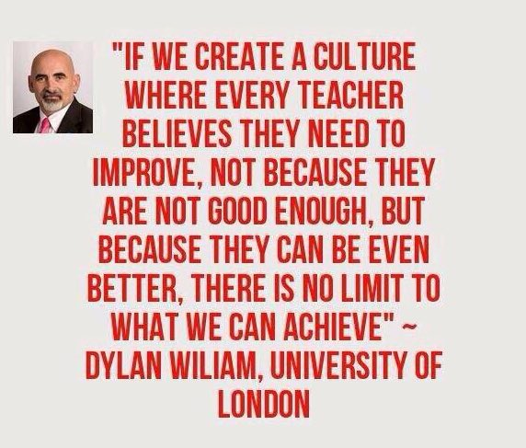

**Cooperative**

**Learning**



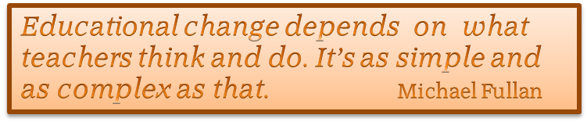

**Glasgow’s Improvement Challenge**

**(Themes four and five)**

* Enhancing the **leadership of senior staff** at all levels; and
* Raising attainment in **secondary schools** through providing additional supported study, mentoring and an **increased focus on learning and teaching.**

**Session 2015 – 2016**

1. A review of Learning and Teaching in the BGE (S1 – S3) took place in twelve secondary schools, examining approaches to improving *Learning and Teaching*, tracking, and assessment and moderation of pupil learning and progress. This review highlighted the need for a focus on consistency in:

* Learners’ experiences, within and across schools, and
* How improvements to Learning & Teaching were led within and across schools.

1. Schools were engaged in reflection around what drives improvements in *Learning and Teaching*, and what value we place on each of the following areas, as a city and in individual schools:

* Policy
* Research
* Agreed methodology / approaches
* Professional Learning
* Self-evaluation
* Observation / feedback
* Collaboration

1. It was agreed that a citywide consistent approach to improving and investing in Learning and Teaching was a priority. There was recognition of the importance of context in our 30 secondary schools across Glasgow and acknowledgement that no single approach should be imposed across the city. However, the work to be done would include collaboration, co-learning, support and robust challenge within and between schools in order that all schools contribute to improvement of the system.
2. A Depute Head Teacher from each school was allocated to lead *Learning and Teaching* as part of a city network that would promote:

• Investment in all of our teachers

• Importance of learning from research and enquiry

• Empowering middle leaders

• Collaboration across schools

**Session 2016 – 2017**

**DHT Learning & Teaching Collaboration**

Our Learning and Teaching DHTs were involved in a number of collaborative workshops exploring what is working well and what is driving improvement in *Learning and Teaching* in each school and across the city. They also had input from Education Scotland <https://education.gov.scot/>:

* *David Gregory* on *The Art of the Consistent* and *Theories of Learning*: *Why teachers do what they do in classes,* from what evidence are decisions about pedagogy made *and Is Learning a Process or an Outcome*
* *Graeme Logan* on *Improving Learning and Teaching* in the context of the NIF, HGIOS 4 and the Pupil Equity Fund

**Learning and Teaching Conference**

Glasgow City Council held a secondary *Learning & Teaching conference* for 500 teacherswith keynote speakers compelling all of our teachers to consider research and evidence to inform practice:

* *Sir Kevan Collins* from the Education Endowment Foundation <https://educationendowmentfoundation.org.uk/about/our-team/sir-kevan-collins/>
* *John Thomsett* from Huntington research school in York <https://johntomsett.com/>

The conference also introduced delegates to the three options for staff professional learning to be delivered in partnership with Tapestry <http://www.tapestrypartnership.com/> and the Co-operative Learning Academy.

* Pedagogy and Equity <http://www.gtcs.org.uk/News/news/news-professional-recognition-improving-pedagogy.aspx>
* Making Thinking Visible <http://www.pz.harvard.edu/resources/making-thinking-visible-how-to-promote-engagement-understanding-and-independence>
* Co-operative Learning

**Middle Leaders’ Conference**

Glasgow City Council held a middle leaders’ conference, attended by 450 Principal teachers or Faculty Heads from across our 30 secondary schools. They explored key messages from Sir John Jones – author of *The Magic Weaving Business* <https://sirjohnjones.com/> in terms of the importance of every teacher and the valuable role Middle Leaders play in creating a caring climate where high aspirations are the norm and all staff recognise the potential of every young person.

**Masterclasses (HTs and DHTs)**

Head Teachers and *Learning and Teaching* DHTs attended Masterclasses led by Dylan Wiliam and Mark Church, as an introduction to our *Pedagogy and Equity* and *Making Thinking Visible* programmes.

**Professional Learning Programme**

Subsequently each school identified a **Professional Learning Pathway**, choosing one or more than one of the programmes on offer – and most schools identified funding for this from the **Pupil Equity Fund** that is allocated directly to schools, targeted at closing the poverty related attainment gap, and spent at the discretion of Head Teachers working in partnership with each other and their local authority. <https://www.gov.scot/policies/schools/pupil-attainment/>

**Session 2017 – 2018**

**Supporting DHTs’ Leadership of Learning and Teaching**

Around 400 secondary teachers embarked on a programme of professional learning choosing from one of more of the two Tapestry Programmes: Making Thinking Visible (Mark Church) and Pedagogy and Equity (Dylan Wiliam) and / or Cooperative Learning Academies. The DHTs formed ten trios (below) and visited each other’s schools twice in the session to help support the practice being developed through the ongoing professional learning and the development of Teacher Leading Communities.

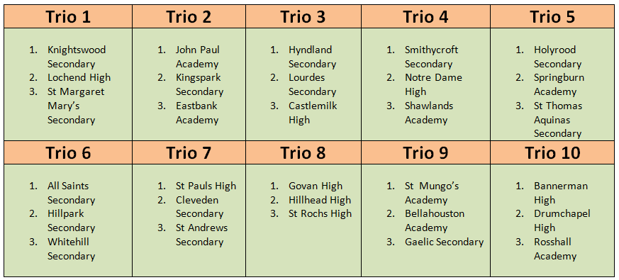

**Supporting DHTs’ Evaluation of Learning and Teaching**

The DHTs were given time and space to reflect on the *HGIOS 4, QI2.3* [*https://education.gov.scot/improvement/documents/frameworks_selfevaluation/frwk2_nihedithgios/frwk2_hgios4.pdf*](https://education.gov.scot/improvement/documents/frameworks_selfevaluation/frwk2_nihedithgios/frwk2_hgios4.pdf) *Learning, Teaching and Assessment* section of the Glasgow City Council Education Perspective Report. This was facilitated by input from David Gregory, HM Inspector, on evaluative writing and models of classroom observation.

**Supporting DHTs’ Professional Reflection**

The DHTs attended four workshops throughout the year, each of which included presentations and time for collaborative reflection on:

1. their leadership and evaluation, of Learning and Teaching, and
2. the practice being developed through the citywide professional learning programmes.

* **September 2017**

David Gregory (Education Scotland) input on evaluative writing and draft Education Perspective Report, and formation of trios

* **October 2017**

Input from practitioners on inter-school self-evaluation models previously trialled and examination of QI 2.3 evaluations in sample Summary of Inspection Findings (Education Scotland)

* **January 2018**

Feedback from first trio visits. Input from Graham Donaldson <http://www.graham-donaldson.com/>

* **May 2018**

Update EPR following 2nd trio visits and evaluation of DHTs’ network activity thus far.

**Session 2018 – 2019**

The DHTs’ collaboration work during session 2018 -2019 is furthering the overarching aim to promote and facilitate excellent learning and teaching in every secondary school in Glasgow, via four workshop sessions and further development of the allocated trios. The programme continues to include time for:

1. collaborative reflection and sharing of practice, and
2. evaluating impact of the citywide professional learning programmes.

There is a further specific focus this session on:

* **Systems Leadership**: how our senior leaders extend their reach beyond their individual school via working in trios, to influence practice more widely in order that every school improves. DHTs agreed principles of systems leadership that would underpin the trio collaboration:
  1. **Common Moral Purpose**: if we have / know something that can help another school, we are morally obliged to offer this.
  2. **Ego free collaboration** is about improving the whole system with a genuine desire for every school to improve and no fear of highlighting what is currently not working well in our own context.
  3. **Sharing our best improves our best**: when asked to share, we examine what we’re sharing, take a closer look at it and further improve it.

Trio visit were organised for this session with the above principles in mind.

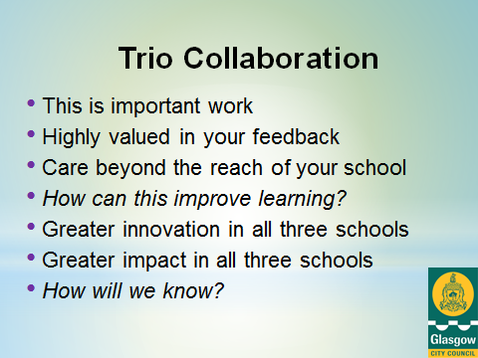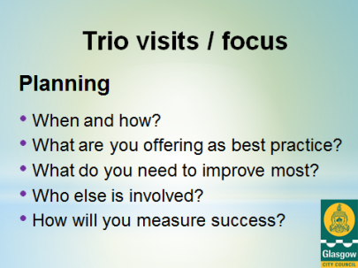

* **Building capacity and sustainability:** The nature of DHT leadership required to build capacity in our middle leaders, our learning communities and in making this focus on continuous improvement in *Learning and Teaching* a sustainable way of working in Glasgow.
* **Meeting learners’ needs**: Examination of the extent to which the new approaches and practices in our classrooms are improving learning and teaching to meet the needs of our increasingly diverse groups of children and young people.

Four workshops are taking place over the session. As with session 2017 – 2018, they include a balance between collaboration, presentations and workshops. Visiting speakers include:

* *Anton Florek*, Strategic Adviser to *The Staff College* <https://thestaffcollege.uk/who-we-are/contact-the-team/>
* *Professor Margery McMahon* – professor of Educational Leadershipfrom the *University of Glasgow* <https://www.gla.ac.uk/schools/education/staff/margerymcmahon/>
* *Dr Richard Niesche* from the University of New South Wales in Sydney, Australia <https://education.arts.unsw.edu.au/about-us/people/richard-niesche/> (TBC)
* *Professor Chris Chapman* from the University of Glasgow <https://www.gla.ac.uk/schools/education/staff/chrischapman/> (TBC)
* *Education Scotland (TBC)*

This session, there is a stronger focus on support and challenge between schools, underpinned by the tenets of collaborative professionalism (Hargreaves and O’Connor, 2018). <http://www.andyhargreaves.com/uploads/5/2/9/2/5292616/seminar_series_274-april2018.pdf>

**Future Planning: 2019 onwards**

**Further development of DHT trio collaboration**

Growth and development of Secondary L & T model of collaboration and improvement, underpinned by research around collaboration.

**Evaluation of impact**

Embed robust, impact focussed self-evaluation processes within the Learning & Teaching trio model.

**GCC: Sustainable model of professional learning**

Sustainable, self-improving secondary DHT trio model as a ‘way of working‘ in Glasgow with identified school staff leading future TLC / MTV training from 2019 – 2020 onwards.

**Coaching to enhance challenge, innovation and impact**

Exploration of adaptation of the Growth Coaching model to support trios’ inter-school challenge, and increase innovation and impact.

**Research: Case Study**

There is interest from the Robert Owen Centre for Educational Change in exploring the work to improve *Learning and Teaching* in our secondary schools as a case study. <https://www.gla.ac.uk/research/az/robertowencentre/>

**Model for ASL Schools**

Adaptation of ‘DHT trio’ model to other sectors as appropriate to context and school structures.