Licensing (Scotland) Act 2005  Notification Form:  Personal Licence Refresher Training |  |  |  |  | 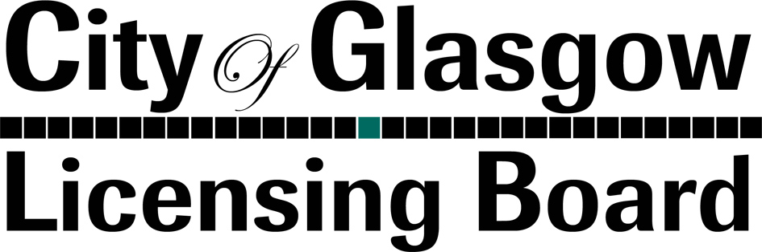
Existing Personal Licence Holders should use this form to advise the Licensing Board that they have obtained an accredited Scottish Certificate of Personal Holder Refresher qualification (SCPHL/R) within the timescales required by section 87 of the Licensing (Scotland) Act 2005
If you are completing this form by hand please write legibly in block capitals.
Section 1. Current Licence Details
1.1 Please provide your Personal Details:
Surname |  |  | First Name(s)
Home Address (Include flat position, house name etc)
Post Town |  |  | Postcode
Current Personal Licence Number |  |  | Date of Birth
Daytime Phone No. |  | Evening Phone No. |  | Mobile Phone No.
Email Address

Section 2: Agent
See Note B |  |  |  |  | Please Tick One Box Only
Is this notification lodged by an Agent? |  |  |  |  | YES | NO
If you have answered ‘Yes’, please complete the sections below
Full Name and Address of Agent
Post Town |  |  | Postcode
Phone No. |  |  | Email Address
Contact Name

Section 3: Checklist
See Note C
I confirm that I have enclosed the following:
Please Tick
- A copy of the relevant Scottish Certificate of Personal Licence Holder Refresher Qualification (SCPLH/R) issued by an accredited body

Section 4: Declaration by Personal Licence Holder
I hereby notify the City of Glasgow Licensing Board that I (a) have obtained the attached Scottish Certificate of Personal Licence Holder qualification from an accredited body; (b) was awarded that qualification on the date indicated on the certificate; and (c) confirm that the particulars given by me on this form are true to the best of my knowledge and belief.
Only the Applicant or the Agent named in Section 2 can sign or amend this application form
SIGNATURE |  | DATE

Notes
A | The information which you provide on this form will be processed by the City of Glasgow Licensing Board (which is the “data controller” for purposes of the Data Protection Act 1988) in order to process your notification. The Licensing Board is under an obligation to properly manage public funds. Accordingly, information that you have provided on this form may be used to prevent and detect fraud, and may also be shared for the same purposes with other public bodies or other organisations that handle public funds.
B | If the notification is submitted by an agent then all correspondence regarding this matter will be directed to the agent.
C | Only a copy of the qualification should be provided with this form. Do not send a copy of the original certificate.  There is no need to return your current Personal Licence. On receiving this notification, the Licensing Board will update their records and forward a replacement training appendix to be attached to your current Licence.

If you further information or guidance the Licensing Team will be happy to assist you. Please note that whilst the Licensing Team can provide guidance, the team cannot offer you legal advice.

You can contact us by phone, fax or email.

City of Glasgow Licensing Board  City Chambers  George Square  Glasgow G2 1DU | Phone: 0141 287 5354  Fax: 0141 287 5357  Email: LicensingBoard@glasgow.gov.uk

FOR OFFICE USE ONLY
Date Received | Final Sub Date | System Updated | Appendix Issued

